**Q1:** Write code of the following class diagram in java.

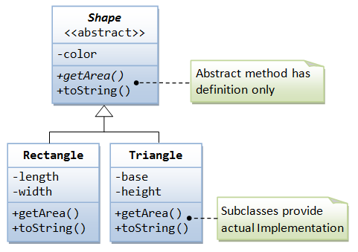

Q2: write code for the following class diagram.

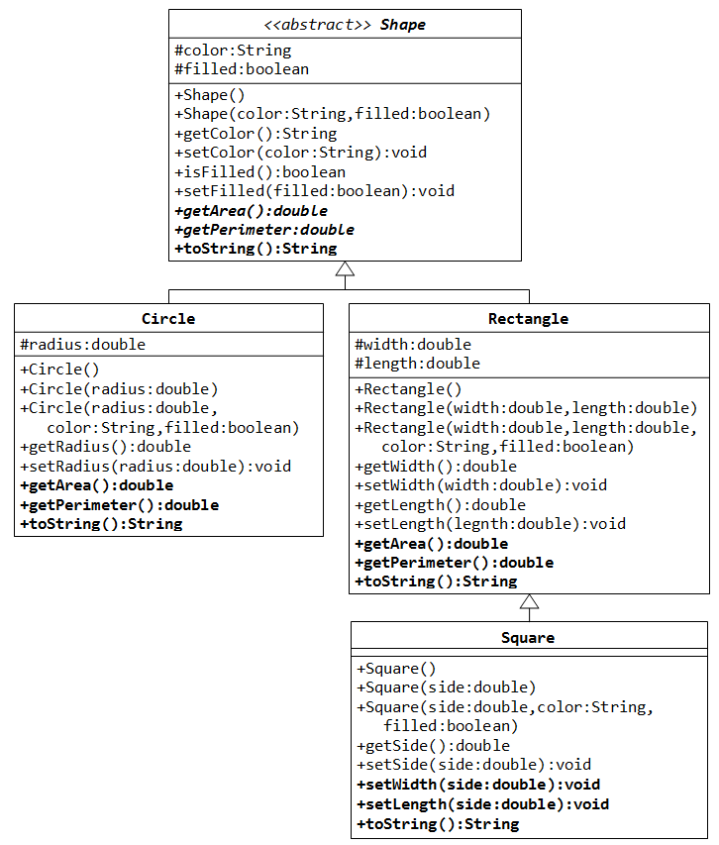

Q3: write code for the following class diagram.

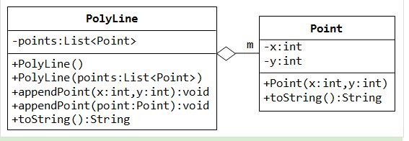

Q4:  A **PhoneDirectory** holds a list of names and associated phone numbers. But a phone directory is pretty useless unless the data in the directory can be saved permanently -- that is, in a file. Write a phone directory program that keeps its list of names and phone numbers in a file. The user of the program should be able to look up a name in the directory to find the associated phone number. The user should also be able to make changes to the data in the directory. Every time the program starts up, it should read the data from the file. Before the program terminates, if the data has been changed while the program was running, the file should be re-written with the new data.